CENWP-OP-B
18 June 2007
MEMORANDUM FOR THE RECORD

SUBJECT: Dead sockeye and fish handling issues at Bonneville’s Adult Fish Facility (AFF).

On 16 June, around 1100, Project Fisheries was inspecting the AFF. During this time, there were several events that caused Fisheries some concern.

- UI researchers found a dead sockeye in the brail pool. The Bonneville Project Fisheries Bio took pictures (see below) and looked for any tags. The fish was a female sockeye with a clipped adipose. Total length = 54.5cm, fork length = 51.5. The fish had some descaling, and looked like its back end may have been smashed in something at some point in time. There appeared to be a hole punch in the caudal fin, but no other tags or injuries were noted.
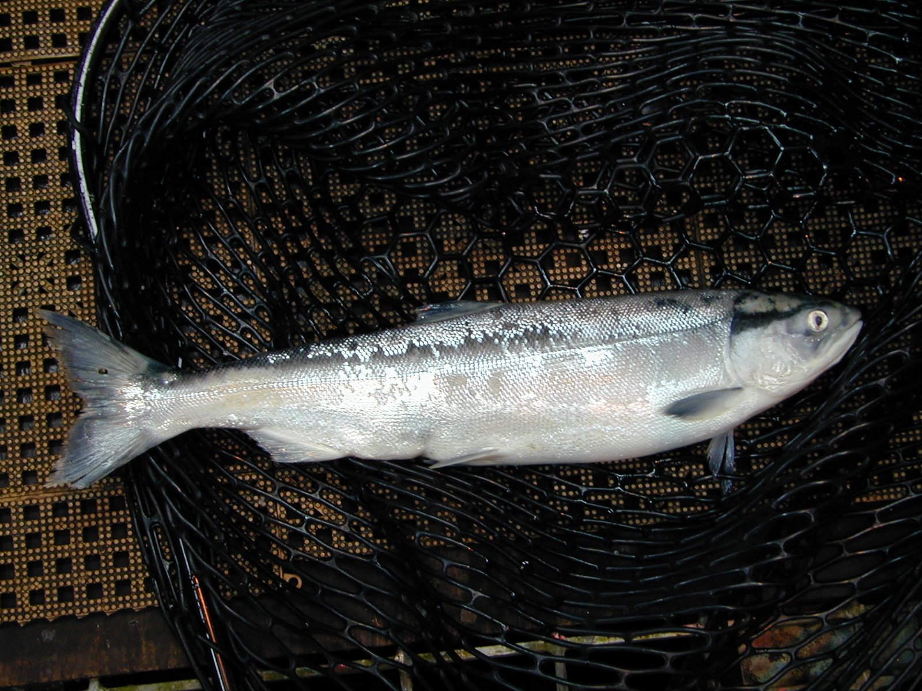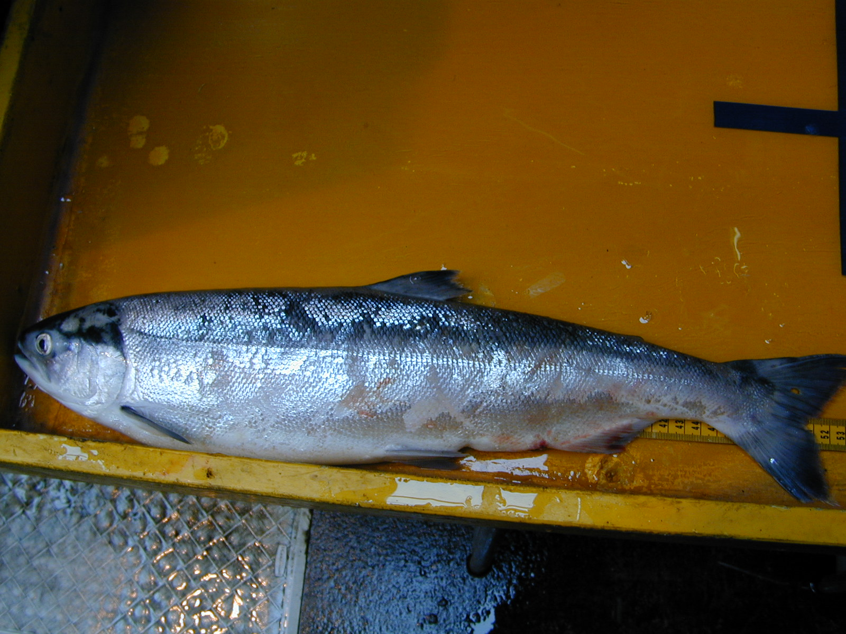

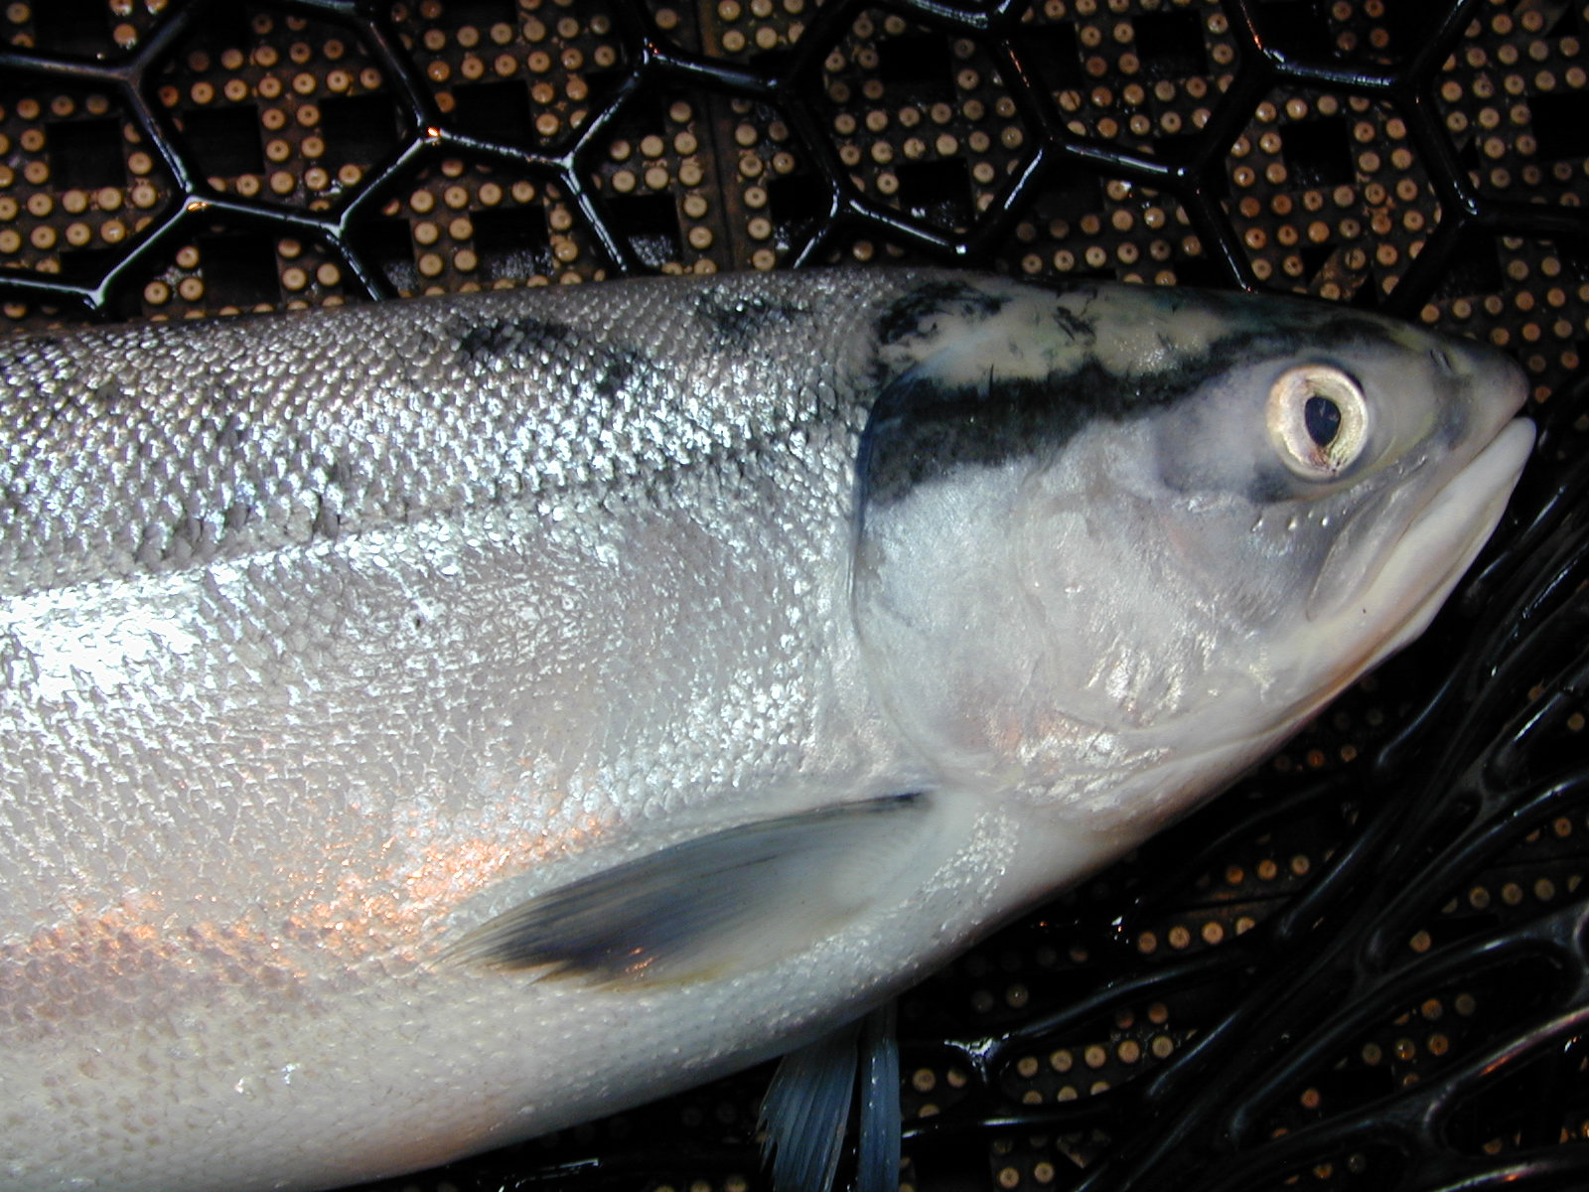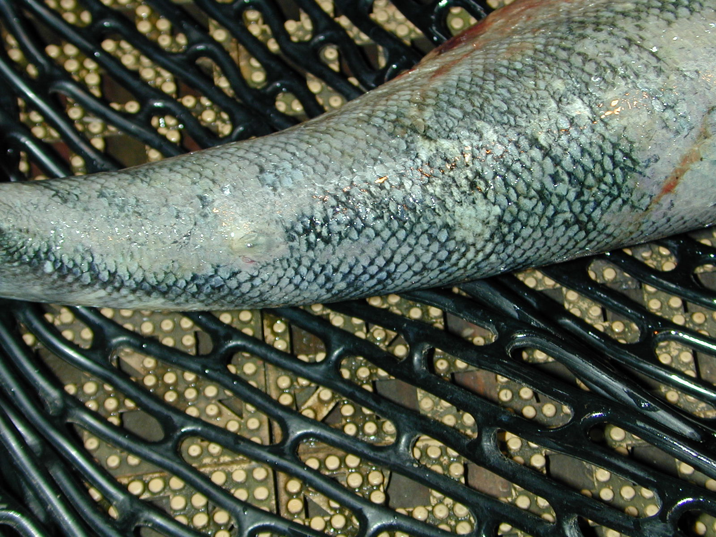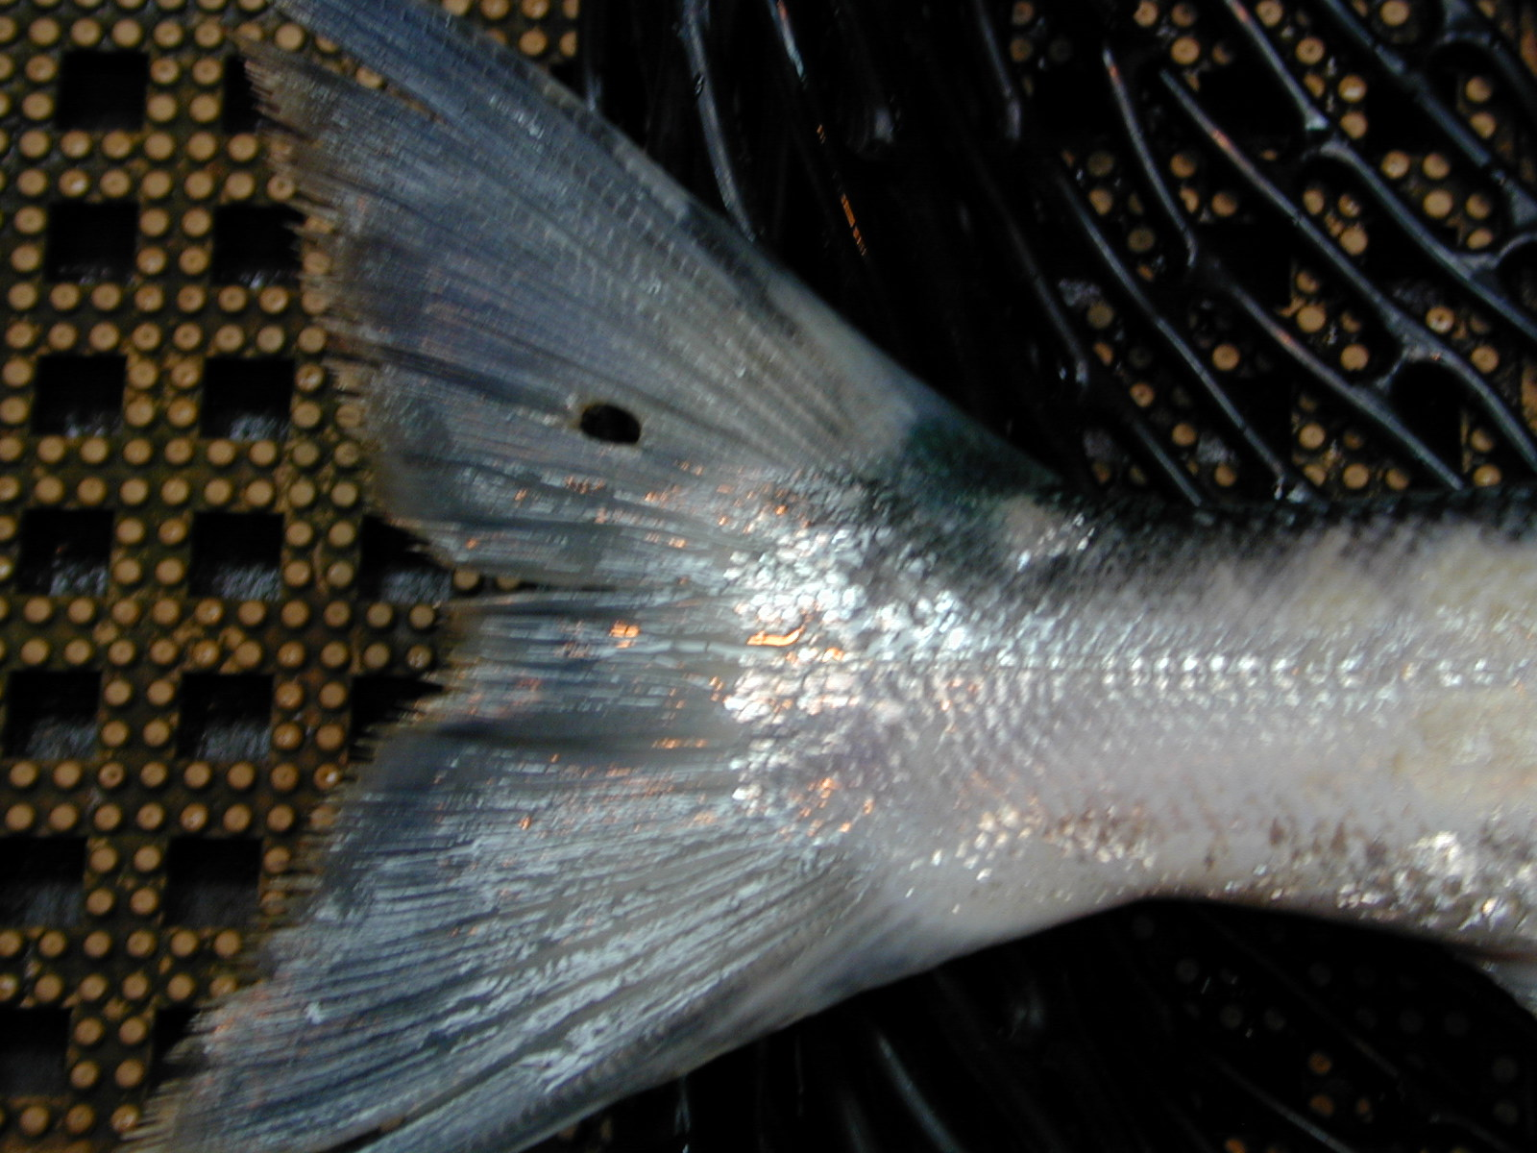

- It was noted by the Project Fisheries bio that the UI shad researcher was operating the switchgate, trying to sample chinook. The shad researcher kept diverting the non-target species into the anesthetic tank. The fish bio witnessed steelhead being diverted into the anesthetic tank, which then had to be handled and moved to the brail pool for recovery.
- During the time Project Fisheries was in the AFF, researchers dropped a chinook and a lamprey on the floor.

Bonneville Fisheries

